Name:______________________________________Date:__________HR:____ Notes#___
Notes 3.1 (Day 1): Algebraic Expressions

Learning Target: Simplify algebraic expressions.

Success Criteria: • I can identify terms and like terms of algebraic expressions.
• I can combine like terms to simplify algebraic expressions.
• I can write and simplify algebraic expressions to solve real-life problems.

Warm Up
Your goal is to get as close to 24 as you can without going over!

Exploration 1
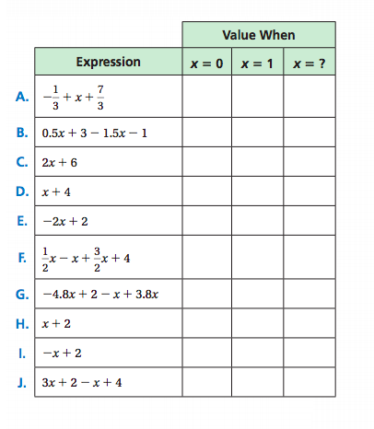
- Choose a value of x other than 0 or 1 for the last column in the table. Complete the table by evaluating each algebraic expression for each value of x. What do you notice?

Show work here:

b. How can you use properties of operations to justify your answers in part (a)? Explain your reasoning.

c. To subtract a number, you can add its opposite. Does a similar rule apply to the terms of an algebraic expression? Explain your reasoning.

Example 1: Like Terms
In an algebraic expression, like terms are terms with the same __________________ raised to the same _______________________. __________________ terms are also like terms.

Identify the terms and like terms in each expression.
3y – 2 – 4y + 6 w + 5w² + 2w² – 7w

Terms:

Like terms:

Example 2 Simplifying Algebraic Expressions
An algebraic expression is in ______________________ ________________ when it has no like terms and no parentheses.

To combine like terms that have variables, use the Distributive Property to add or subtract the coefficients.

Simplify: 4y – 12y –3.7h + h – 13.5h

Simplify: 8u + 5w – 3w + 7u 6d – 5 – 4d + 6

Name:_____________________________________Date:__________HR:____Notes#_____
Notes 3.1 (Day 2): Algebraic Expressions

Learning Target: Simplify algebraic expressions.

Success Criteria: • I can identify terms and like terms of algebraic expressions.
• I can combine like terms to simplify algebraic expressions.
• I can write and simplify algebraic expressions to solve real-life problems.

Warm up
What are the like terms in the expressions? Then, simplify the expressions.

4x + 3y – 8.5x + 5 + 3z – 8 -4y + 3x² + -14.3y – 4.5x² + 18

Example 3 Modeling Real Life

Verbal Model

Identify the Variable

Expression

