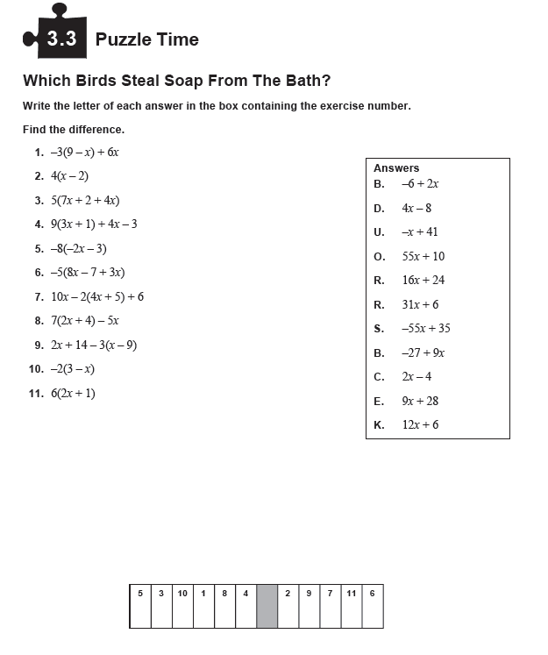
Name: ______________________________ Date: ____________ Hour:____ HW#25

