Name:_______________________________________Date:__________HR:____ Notes: _15__
Notes 3.4 (Day 1)
Factoring Expressions
Learning Target: Factor algebraic expressions.

Success Criteria: I can identify the greater common factor of terms, including variable terms.
I can use the Distributive Property to factor algebraic expressions.
I can write a term as a product involving a given factor.

When ____________________________________ an expression, you write the expression as a product of the factors. You can use the Distributive Property to factor any rational number from an expression.
Example 1 Factoring Expressions
Factor the following Factor out the coefficient Factor out a negative number.
using the GCF. of the variable term.

6x – 27 $\frac{1}{5}x-\frac{4}{5}$ –12r – 20

You Try It!
36k + 45 $5+2.5d$ -10y + 25

Explorations

Can you find out what factors could be used to create the given areas?

? ? Show this using the Distributive Property.
35
28

?

? ?
45
25

?

? ?
42
18

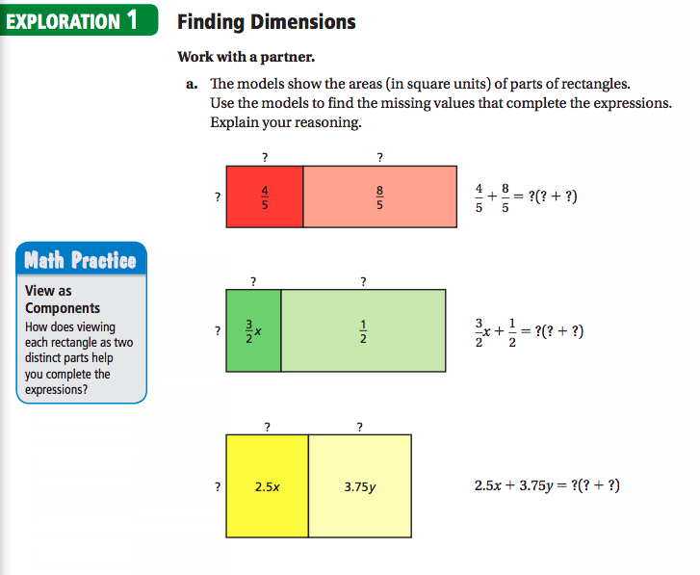
Are the expressions you wrote in part (a) equivalent to the original expressions? Explain your reasoning.

Explain how you can use the Distributive Property to find rational number factors of an expression.

Name:_______________________________________Date:__________HR:____HW#25
HW#25: 3.4 Factoring (Day One)

