Name(s)_______________________________________________ Period ______ Date ___________________

 | Activity Guide - Licensing Your Work | 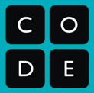

Creative Commons
The Creative Commons license allows content creators to specify exactly the permissions and restrictions of their creation. The Creative Commons license is made up of multiple components that you can mix and match to customize the restrictions you want to place on your work.

Icon | Abbr | Description |  | Icon | Abbr | Description
 | BY | Attribution: Others who use this work must give credit to the original author. |  |  | SA | Share-Alike: Users of this work must share any derivative works under the exact same license.
 | NC | Non-Commercial: Others may not use this work for advertising or to make money. |  | 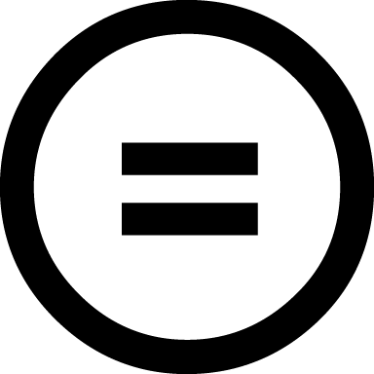 | ND | No Derivative Works: Users may only use this work as is and may make no modifications.

Choosing the Right License
For each of the scenarios below identify the least restrictive Creative Commons license that meets the need of the content creator and explain why you chose that license.

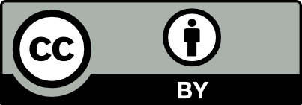  CC-BY | 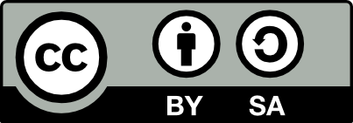  CC-BY-SA | 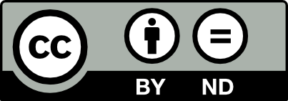  CC-BY-ND | 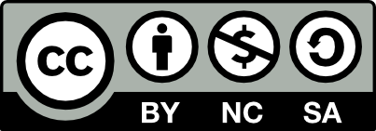  CC-BY-NC-SA

Scenario 1
Ernesto loves to sketch and posts all of his drawings on his art blog. Lately people have been taking his art and turning them into memes by adding snarky text to the bottom. Ernesto likes the idea of people sharing his work more broadly, but he doesn’t want people to mess with his original art.

- What is the least restrictive CC license that ensures Ernesto’s rights are preserved? Why?

Scenario 2
Maggie and Eric record short keyboard and guitar riffs which they trade with each other to make larger songs. They dream of one day having a real musician sample their riffs in a song, they just don’t want people to use their recordings without giving them credit.

- What is the least restrictive CC license that ensures Maggie and Eric’s rights are preserved? Why?

