Name_______________________________________Date_____________________Notes# 1
Notes: Comparing and Ordering Integers

►Two numbers that are the same distance from _____________ on a number line
are called __________________________

►___________________ are the set of positive whole numbers, their opposites and zero. Below are some real world examples of integers
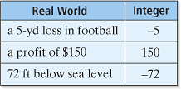

►The _______________ _______________ of a number is it’s
___________________ away from zero on a number line. The symbol is $\left|\right|.$
Example: $\left|-3\right|$ $\left|14\right|$
Example 1 Finding Opposites
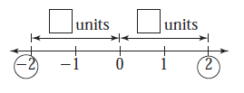
Find the opposite of 2. To do this, look on a number line.

You Try It!
Find the opposite of each number. Use a number line if needed.
- – 8 b) 12 c) 4

Example 2 Finding Absolute Value
Find $\left|-5\right|.$ Use a number line to help. Remember, always start at zero!
1
3
4
5
– 1
– 5
– 3
– 2
2
– 4
0

You Try It!
Find each absolute value. If needed, use a number line to help. Remember, always start at zero!
- $\left|4\right|.$ b) $\left|-2\right|.$ c) $\left|0\right|.$

►When we have a number line the numbers to the left of zero are ____________________ and _____________________ while the numbers to the right of zero are _________________________ and ___________________________.
1
3
4
5
– 1
– 5
– 3
– 2
2
– 4
0

Negative and decreasing Positive and increasing
Example 3 Comparing Integers
Compare – 8 and 3 using a number line. Use <, > or =.

You Try It!
Compare each integer using <, > or =. Use a number line if needed.

- – 6 4 b) 2 0 c) 4 – 4

Example 4 Ordering Integers
Arrange the cities by temperature, coldest (lowest) to warmest (highest) on a number line.
City | Low
Albuquerque, NM | 8
Chicago, IL | -8
Cleveland, OH | -5
Columbia, SC | 4
Providence, RI | 1
Reno, NV | -2

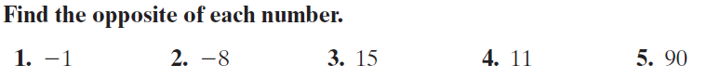

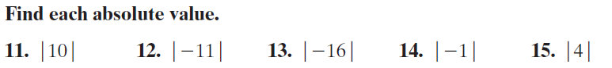

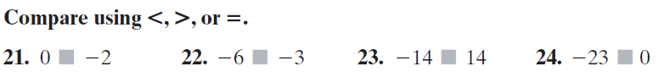

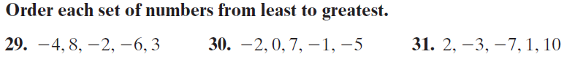

Name_______________________________________Date_____________________HW# 1
HW: Comparing and Ordering Integers

