Add each integer given the number line provided.
Name_______________________________________Date_____________________HW#___2___
Adding Integers on Number Lines & Chips

$1. -5+(-4)$
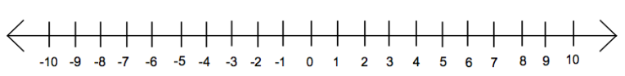

$$2. 2+(-8)$$

$3. -6+7$

$4. 10+(-7)$

5. $7+3$

6. $-2+(-3)$

For the following problems, solve using chips. Show your circles.

7. $-9+6$

8. $-5+5$

9. $-8+(-1)$

10. $5+(-6)$

11. $-10+7$

12. $-4+(-6)$

Choose your favorite method for the last three problems! Number line or chips!?

13. $2+(7)$ 14. $-1+(-7$) 15. $-3+8$

