Name(s)_______________________________________________ Period ______ Date ___________________
Activity Guide - The Problem Solving Process

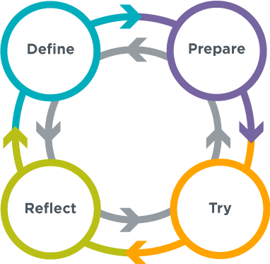
The Problem Solving Process
Having a strategy for approaching problems can help you develop new insights and come up with new and better solutions. This process is generally useful for solving all kinds of problems.

Define
  - What problem are you trying to solve?
  - What are your constraints?
  - What does success look like?

Prepare
  - Brainstorm / research possible solutions
  - Compare pros and cons
  - Make a plan

Try
  - Put your plan into action

Reflect
  - How do your results compare to the goals you set while defining the problem?
  - What can you learn from this or do better next time?
  - What new problems have you discovered?

What it Looks Like
You’re going to list the strategies and processes you and your classmates already use for each step in this process. Fill out the tables below for each of the three problems.

Aluminum Boat Challenge
For each step in the Problem Solving Process list the parts of this activity you believe fall within that step

- Define

- Prepare

- Try

- Reflect

What strategies did you use in solving this problem that could help you solve other problems?

A Problem You Are Good at Solving
You should have brainstormed a type of problem that you’re good at solving. Write down the steps of your process that you believe fall into each step of the Problem Solving Process

Type of Problem: __________________________________________________________

- Define

- Prepare

- Try

- Reflect

What strategies do you use in solving this problem that could help you solve other problems?

A Problem You and a Classmate Want to Get Better at Solving
Find a classmate and talk to figure out a type of problem you both could get better at solving. Fill out the questions below with strategies or steps you would want to use to try to solve this problem using the problem solving process.

Type of Problem: __________________________________________________________

- Define

- Prepare

- Try

- Reflect

What strategies could you use in solving this problem that could help you solve other problems?

