Name: ________________________________________ Date: ___________ Hour: _________
Warm-Up: Combining Representations
- Can you decode this binary string?

What information do you need to decode this string? _____________________________
________________________________________________________________________

- Use the Student Record to answer the questions below:
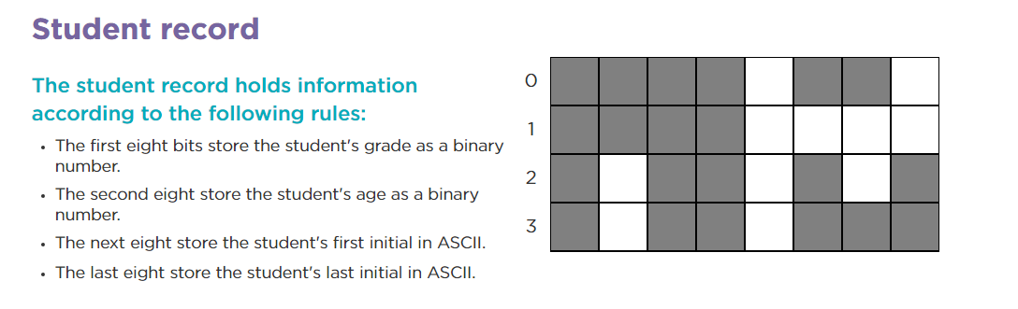

What grade is the student in? ___________
How old is the student? _____________
What is the student’s first initial? _______________
What is the student’s last initial? ________________

- Can you code your grade in binary? 4) Can you code your age in binary?

5) Can you code your initials in binary?

