Computer Science Discoveries Syllabus ~ Mrs. Matteo
E-mail: joanna.matteo@uticak12.org
Remind: Text @csdeppler to 81010
Prep Hour: 5th Hour
Website: mrsmatteo.weebly.com

What will we study in this class? This year will be fast-paced and exciting as we discover Computer Science and the creativity and fun of computers. Our units cover problem solving, web development, interactive games and animation. In this class, we will be learning the computer languages of HTML and JavaScript. Students will be logging into code.org, setting up an account, and completing various lessons throughout the semester.

What should I bring to class? Students will need to bring a 3-Ring Binder or Folder to class every day to keep their handouts and materials in there. A pen or pencil is also required since we will take notes, journal or complete handouts in class. Some students may wish to bring headphones or a wireless mouse, but these are provided and not required.

Grading Criteria: Your grade will be based on Total Points based on Projects, Journals, Class Activities and Participation.

Technology:
- Cell phones should not be out, unless I specifically tell you they are allowed to be out.
- All laptops should be handled with care and carried with 2 hands at all times.
- The attached form for acceptable use of technology must be signed by the student and turned in no later than Friday, Jan. 24th.
- There will be both plugged (computer use) and unplugged days in this class. You will be assigned a computer number to use for the year.

Expectations:
- Teacher is the Lead Learner
- Students work together in pairs frequently
- Students will problem solve, persevere, collaborate, communicate, and be creative
- Students can be successful with the material regardless of the skill set they have when they enter the class; what they achieve depends on what they put in to the class
- Students will learn through discovery

Late/Make-Up Work:
- The expectation is that you submit all assignments on time. You will be completing pair and small group work, so consistent attendance is important. We move ahead every day, too many absences will make it difficult to stay with the class.
- If you are absent, it is your responsibility to follow proper procedures to ensure that you receive your work. Check mrsmatteo.weebly.com for assignments or get a hard copy from the class crate. Most work can be completed on-line though code.org at home.
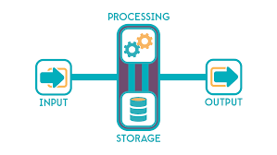

Unit 1: Problem Solving
Students will learn the problem solving process, the input-output-store-process model of a computer and how computers help humans solve problems. Students end the unit by proposing their own app to solve a problem.
Unit 2: Web Development
Students learn to create websites using HTML and CSS inside Code.org’s Web Lab environment. Throughout the unit students consider questions of privacy and ownership on the Internet. Students develop a personal website throughout the unit.
Unit 3: Animations and Games
Students learn many fundamental programming constructs and practices in the JavaScript programming language while developing animations and games in Code.org’s Game Lab environment. Students end the unit by designing their own animations and games.
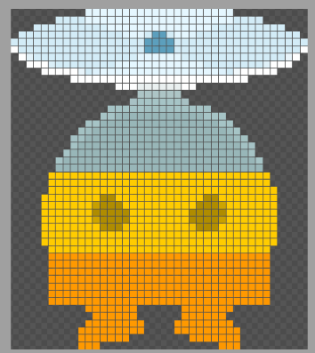

Technology Use Non-Negotiables: Computer Science Discoveries
The use of technology at Eppler Junior High School is a privilege with responsibility. Failure to abide by the following guidelines will result in the loss of performance points and/or computer privileges.
- Students will not attempt to modify the appearance or operation of any technology equipment. This includes, but is not limited to:
  - Commands, copying or installing software,
  - Setting passcode locks
  - Copying files of any type. Each one should remain in its original or teacher-set configuration.
- Tampering with or vandalizing hardware, software, or data will not be tolerated. It is each student’s responsibility to check the computer before and after use and report problems to the teacher immediately.
- Students will return all equipment to its designated slot and connected to chargers or stations as necessary.
- Students may use personal headphones or use school headphones, when instructor of current class approves use.
- Students will only use applications, software and programs required for completing assignments/projects. Only those who been approved by the teacher of the current class will be used in classes. Failure to stay “on task” may result in the loss of performance points, technology privileges and/or further disciplinary actions. Students should not use personal or school equipment to play online or video games.
- No food or drink is allowed near any technology at Eppler.
- Students may use the Internet when authorized and must abide by the conditions of district Internet Acceptable Use Policy.
- A student using the Internet may visit only teacher-approved sites. Game sites are not allowed.
- Student will report any web site that displays inappropriate content or images to the teacher immediately without showing it to other students.
- Students will report any cyber-attacks, cyber-bullying, or inappropriate texting received to the teacher for help resolving the issue.
- No web sites, software, apps or media should be printed, shared, E-mailed or downloaded without teacher approval.
I understand that if I violate any of the rules stated above or perform any other disruptive technology-related actions I will be subject to loss of technology privileges, will receive a written referral (minor or major) and may be subject to further administrative discipline actions.
-------------------------------------------------------------------------------------------

Student Signature: ___________________________Date: _________

