Name: _____________________________________________ Date:______________ HW: 10

HW- Order of Operations Worksheet
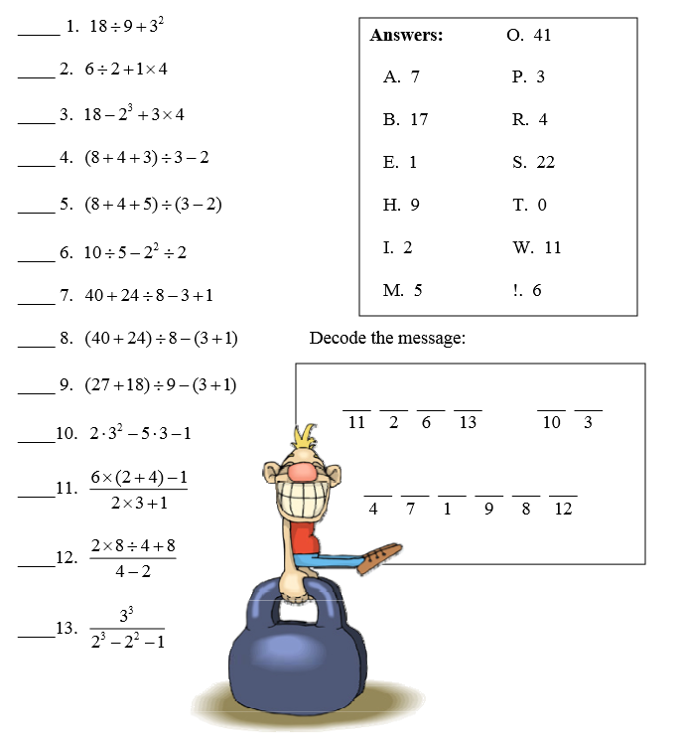
SHOW ALL WORK ON A SEPARATE SHEET OF PAPER!!

