Name(s)_______________________________________________ Period ______ Date ___________________

 | Activity Guide - Keeping Data Secret | 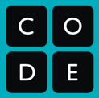

Encoding and Decoding
Here are the binary codes for the emojis that you will use in this lesson.

Use the chart above to decode the following message:

_____________ _____________ _____________

Encryption and Decryption
Here’s a message that has been encrypted. Encrypted messages have been changed so that only some people are able to read them. Try to use the chart to decode the message.

Before you can read this message, you will need to decrypt it. When you decrypt a message, you make it readable again. In order to decrypt this message, you’ll need to know the algorithm and the key.
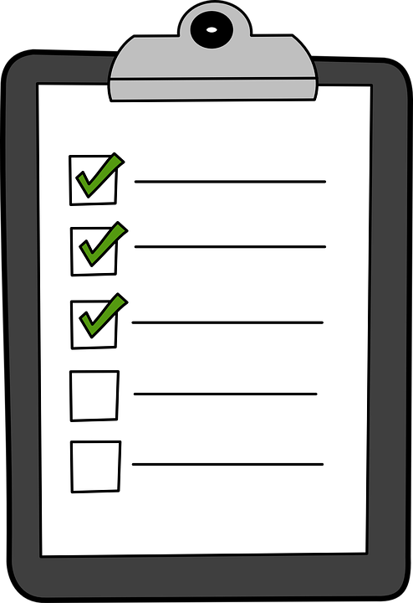  The algorithm is the method that you use to hide your data. | 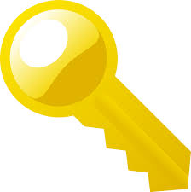  Your key is the code that you use in the algorithm to keep your message secret.

Key:
Algorithm: Step 1: Copy the encrypted message into the first row. (The first six bits are done for you.)
Step 2: Copy the key into the second row, and keep repeating it until the end. (The first eight bits are done for you.)
Step 3: For each bit in the third row, if the two bits above it are the same (both white or both black), color it black. Otherwise, leave it white. (The first six bits are done for you.)

Encrypted Message
Repeated Key
Decrypted Message

What is the message? ______ ______ ______

Name(s)_______________________________________________ Period ______ Date ___________________

Activity Guide - Keeping Data Secret

Use the same algorithm to decrypt the following message. This time the key is different.

Key:

Encrypted Message
Repeated Key
Decrypted Message

What is the message? ______ ______ ______

Encrypt Your Own Message

You can encrypt a message the same way that you decrypted it. Put your unencrypted message on the top row, your repeated key on the second row, and make the encrypted message by coloring in every bit that has two of the same bits (two white or two black) below it.

What is your message? ______ ______ ______ What is your key? _______________________

Unencrypted Message
Repeated Key
Encrypted Message

Post the encrypted message somewhere everyone in the class can see it.

Why can’t you decrypt any of the messages yet, even though everyone used the same algorithm?

____________________________________________________________________________________________

Decrypt a Classmate’s Message

Write down your key and trade with someone else, then use the key to decrypt that person’s message below.

Encrypted Message
Repeated Key
Decrypted Message

What is the message? ______ ______ ______

